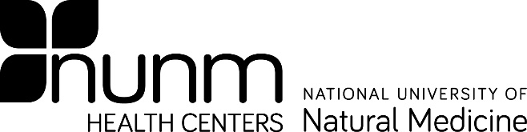
Form B

Source Individual/Patient CONSENT FOR LABORATORY TESTING

Bloodborne Pathogen Post-Exposure

I have been informed that during the performance of his/her/their duties, an employee/student of NUNM was exposed to a bodily fluid of mine. In order to asses and minimize the risk to the exposed individual, I (please check the statement that best applies)

Do Do NOT _____

give consent for a sample of my blood to be tested by a licensed laboratory to detect the presence of infectious organisms including Hepatitis B, Hepatitis C and Human Immunodeficiency Virus (HIV). I have been advised of the side effects of a blood draw.
I understand that the tests will be conducted in a confidential manner so as to protect my identity. I also understand that this test will not be charged to me.

Results of the blood draw will be made available to my personal physician,
Dr. , and to the NUNM Exposure Control Officer in order to comply with state and federal regulations.
Physician Phone Number
Physician Address
Physician Name

Date
Patient Signature
Print Patient Name

Date
Witness Signature
Print Witness Name

Updated 11/4/2021

