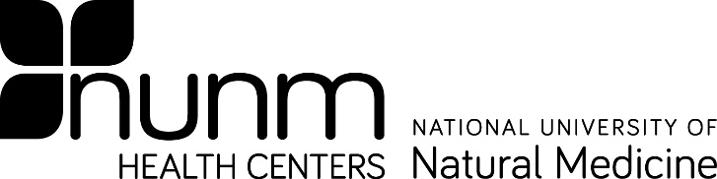
Form C

Exposed Individual CONSENT FOR LABORATORY TESTING

Bloodborne Pathogen Post-Exposure

On , I was inadvertently exposed to a potentially infectious bodily fluid. In order to assess and minimize the risks associated with this exposure, I

Do Do NOT

give my consent for a small amount of blood to be drawn from me to detect the presence of disease including Hepatitis B Virus, Hepatitis C and HIV. I have been advised of the side effects of a blood draw. I also understand that the tests will be conducted in a confidential manner that this test will not be charged to me.

Results of the blood draw will be made available to my personal physician,
Dr. , and to the NUNM Exposure Control Officer in order to comply with state and federal regulations.
Physician Phone Number
Physician Address
Physician Name

Date
Exposed Individual’s Signature
Print Exposed Individual’s Name

Date
Witness Signature
Print Witness Name

Updated 11/4/2021

