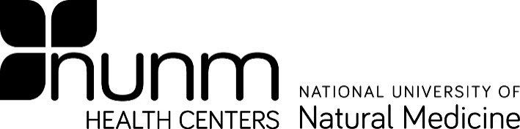
Form D

Off-Site Laboratory Testing Authorization

Bloodborne Pathogen Post-Exposure

INSTRUCTIONS: In the event that the NUNM laboratory is closed and testing must be done at an off-site location, please give this information to the front office personnel at the healthcare facility conducting to the post-exposure testing.

Request an Occupational Exposure/Blood Borne Pathogen Screening (HIV/Hepatitis B&C)

Employer: National University of Natural Medicine 49 S Porter Street
Portland, OR 97201 Employer Contact: Director of Human Resources Account number for employees: 024 0041 OEEWCT
Student contact: Dr. Jessica Nagelkirk
NUNM Health Center
3025 S Corbett Ave.
Portland, OR 97201 503-552-1874 (office)
906-235-5950 (cell)

Account number for students: 85025-12 (Exposure-outsourced)
Physician: If you have provided treatment for an on-the-job injury for an NUNM employee, send Workman’s Compensation form 827 to:

Oregon Educational Employers Workers’ Compensation Trust (OEEWCT) C/O Empire Pacific 5300 Meadows Rd- 300
Lake Oswego, Oregon 97035

Phone: 503-968-6300
Fax: 503-968-6305

Emergency Room Physician: If possible, refer injured worked to an occupational specialist for follow-up care.

I would like the results of the blood draw to be made available to the NUNM Exposure Control Officer, Dr. Jessica Nagelkirk.
Date
Student/Employee/Source Individual’s Signature
Print Student/Employee/Source Individual’s Name

Updated 11/4/2021

