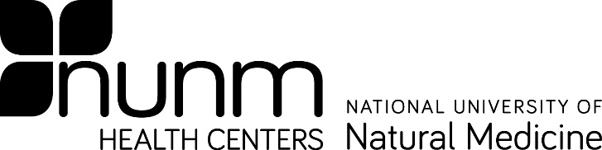
Form E
MEDICAL EVALUATION WAIVER

Bloodborne Pathogen Post-Exposure

On (date), I was involved in an exposure incident involving potentially infectious bodily fluids during the performance of my duties (describe incident below):

By initialing next to each of the following, I acknowledge:

That I have informed my health center supervisor (for students) and the NUNM Exposure Control Officer/Chief Medical Officer at the National University of Natural Medicine (NUNM) Clinic of the details of my exposure incident in writing;

That NUNM has made available to me, at no cost to myself, confidential medical evaluation and follow-up, provided by a licensed health care professional;

That NUNM has also offered to confidentially identify and test the source individual, at no cost to them, where feasible and permitted by law;

That I will be made aware of the results of testing of the source individual, where feasible and permitted by law;

That the free medical evaluation available to me includes collection and testing of my blood for Hepatitis B virus, Hepatitis C virus, and HIV serological status;

That the free medical evaluation and treatment includes post-exposure prophylaxis, when medically indicated, if I so desire;

That the free medical evaluation and treatment includes expert medical advice, evaluation of reported illnesses and counseling;

I understand that I may elect to have the evaluation at a later date.

I am fully aware of risk of disease transmission involved in the performance of my duties, and I have been provided with training and education at NUNM concerning these hazards.
Nevertheless, I voluntarily decline to participate in the post-exposure evaluation and follow-up.

Student, Patient, or Employee Printed Name:

Student, Patient, or Employee Signature: Date:

Witness/NUNM Representative: Date:

Updated 11/4/2021

